Unit 15.A. Website Development

Youssef Shetta

2019

Contents

A1 Purpose and principles of website products 4

Purpose of websites 4

Product and/or service-based website 5

Requirement of websites 5

User-friendly 5

Consistent 6

Navigational 6

Customisable 6

Responsive 6

Principles of website design 6

Usability 6

Example of usability 6

White space/spacing 7

Example of White space/spacing 7

Site layout 8

Example of site layout 8

Accessibility 8

Example of Accessibility 9

Navigation 9

Example of Navigation 9

Typography 10

Example of Typography 10

Alignment 10

Example of Alignment 10

Clarity 11

Example of Clarity 11

Consistency 11

Example of consistency 12

Accuracy 12

Example of Accuracy 12

Content 13

Example of content 13

Media and objects 13

Example of media and objects 13

Simplicity 14

Example of simplicity 14

A. P1 Compare the principles of website design used in two websites, including their suitability for the intended audience and intended purpose 15

McDonalds Aims 15

Wendy’s Aims 15

McDonalds 16

Wendy’s 16

A. M&D1 Analyse & evaluate how the principles of website design are used to produce creative, high performance websites which meet client requirements. 17

Media and objects 18

Position 18

Example of Position 18

Colour 19

Example of Colour 19

Contrast 19

Example of Contrast 19

Size 20

Example of Size 20

Appropriateness 20

Example of Appropriateness 20

Creativity and innovation 21

Example of creativity and innovation 21

Unconventional layouts (outside of the box) 21

Example of unconventional layouts 22

Golden ratio 22

Example of Golden ratio in websites 22

Search engine optimisation 23

Example of search engine optimisation 24

Indexing (Meta tags) 25

Keywords 25

Importance of updates 25

A2 Factors affecting website performance 26

Where scripting runs 26

Browser compliance 26

Server-side factors 26

Bandwidth availability 26

File types 26

Number of hits 26

Client-side factors 26

Upload and download speeds 26

Example of upload and download speeds 27

Processor speed 27

Cache memory 27

Interactivity 27

# A1 Purpose and principles of website products

In this section of the report I will be talking about why certain principles are used on two different websites and I will be comparing them to figure out the most successful web design based on figures. I will be trying to maintain the comparison of McDonald’s website and Wendy’s, they are both fast food competitors, so I well be looking for what they have done to one up each other to keep that competitive edge that they might have.

## Purpose of websites

Websites are made in the same way but are made for different reasons for example, the development of Web 2.0 has enables users to interact and add their own content, and this could be their knowledge about something or their opinion on something. I will be listing a few developments that Web 2.0 has influenced:

* Wikis- Places where all users can contribute to information.
  + - * Example of wikis- Fandom is a website that has a feature that allows users to create wikis of their own based on a game or show. <https://www.fandom.com/explore>
* Blogs-Online journals that include tools for readers to comment and contribute to the community.
  + - * Example of Blogs- Tumblr is a website that lets users post on and create blogs on whatever content they want. [https:/www.tumblr.com/](https://www.tumblr.com/)
* Social networking- social media websites provide tools that enable the users to correspond by posting status updates or posts on the website, they can also have private conversations and play games together. Most social media websites have a “friend” or “follow” button where you are able to have a constant feed of content from that user or keep getting updated every time something changes on their profile.
  + - * Example of social networking- An employee from IAC went on vacation to Africa and used twitter before boarding the plane saying that “Going to Africa. Hope I don’t get AIDS. Just kidding. I’m white” and when she landed she got an email saying that she was fired, this is an example of how socially a person is linked to their job in social media, using the fact they work at a good company can get them a lot of contacts but it can also back fire if they use it in a disrespectful manner.<https://careers.workopolis.com/advice/6-people-who-were-fired-for-social-media-posts/>
* Online applications- online applications allow users to use programs via the internet, this is better as the user does not have to buy the application or download it on their local drive. This means that they are able to access the application from anywhere.
  + - * Example of online applications- Google has a lot of applications that they have on their “product” page, for example they have an application called “drawing” another example of an application google has is google docs.
* Podcasting- a way of making audio or video files available on the internet that can be listened to or viewed.
  + - * Example of podcasting- BBC has their own podcast where they a lot of stations that the user can pick from to listen in. <https://www.bbc.co.uk/podcasts>

## Product and/or service-based website

|  |  |  |  |
| --- | --- | --- | --- |
| Service | Example types | Target audience | Key benefits |
| Commerce | * eBay * Amazon * Online Banking | * Consumer | Allows the user to carry out transactions easily and conveniently on a PC or Mobile device. |
| Real-time information | * 24/7 news updates * Travel information * Weather reports | * Information seekers | Provides immediate up-to-date information. For example the news app on most phones provides this service. |
| Communication | * Blogs * Skype * Email * Online Gaming | * Social networkers * Information seekers * Online Gamers * Adult and teenage consumers | You can receive immediate replies from anyone at no additional cost to your broadband or mobile fee. |
| Download services | * Music download * Film download * Software download * Game download * Steaming services | * Information seekers * Entertainment seekers * Online gamers * Adult and teenage consumers | Flexibility and convenience of downloading different mediums to your PC or mobile device. Also you are able to stream online content to your television or computer as well as you mobile device. |
| Virtual learning environments  (VLEs) | * Moodle * Pearson’s active learn digital service * Blackboard Inc. | * Information seekers * Consumers (teachers and learners) | Many benefits as learners have the flexibility of downloading information from the comfort of their own home. |

## Requirement of websites

Bellow will be the key requirements of all websites:

### User-friendly

It’s easy to use and understand. If it’s easily understandable the visitors would be able to traverse the website with ease, which then leads them to possibly coming back as it did not lead to much hassle to get the information they wanted. For example YouTube is easy to use because everything is laid out in a way that the user is able to see all the buttons that would lead them in the way they want. Like the subscribed button, it shows the content that they subscribed to. It is also mobile integrated which lets the user access the website from anywhere they want.

### Consistent

Consistency is keeping things the same, which is a key principle in website design. For example what you want to keep consistent would be the navigation bar, the design of the website (background, colour, and header). All successful websites have this consistency as it does not confuse the visitor when they first come to the website, as the information would be everywhere and they would not be able to navigate to the thing they want.

### Navigational

The ease of users to navigate and find information that they came for. The more complex the navigation on the website is the more the user will be wanting to stay on the website as the information they seek would be too difficult to search for, which in turn would not make them come to that website again. Good navigation bars would stay the same no matter where you go on the website so the visitors know where things are.

### Customisable

Allows the user to change settings on the website for example if the background is light or dark or if they could get notifications on whither reports or news about specific areas that they are around. For example repl.it has the feature to change the colour of the background from light to dark and back. Also apps which are based on websites allow the user to change if they get a notification or not for certain events.

### Responsive

Responsive websites are those that are optimised to automatically adapt to the layout of the web browser you are using. This also means mobile browsers, it’s only responsive when it’s able to integrate to mobile and other devices. This is because they don’t want the user to scroll and zoom in excessively because if they do it will seem tedious to get what they want (information/entertainment).

## Principles of website design

These principles of web design are the most used principles as they allow the website to be as successful as they can be.

### Usability

The ease of use of the website is how user-friendly it is. For example if it works on all devices, which means the way it’s laid out has to be able to get compacted and viewable from a small portable device.

### Example of usability

An example of a website that utilises this usability principle is YouTube, you are able to access the website on all devices, phones, PC and laptops. This lets the organisations get more clicks on their website due to the way they set up the accessibility from all devices. Another way YouTube meets this principle is by having functions like the search bar and the subscription bar where it shows who you have subscribed to and what content they uploaded, this is very effective for people who are seeking entertainment. <https://www.youtube.com/>

### White space/spacing

These are the spaces on the webpages that are left untouched in the development stage, this is used to make sure that all the information is set up in a way that the viewer can see it in a presentable way, if there was no white spacing the website would be too clustered and if there is too much white spacing the website would not be pleasant to look at.

### Example of White space/spacing

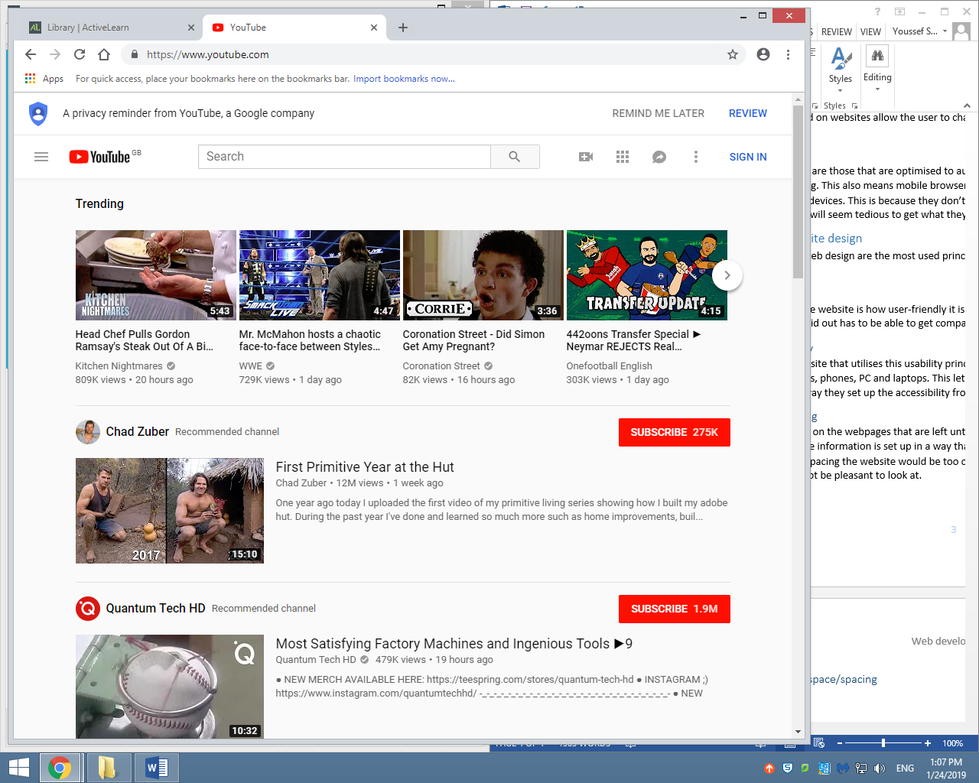YouTube utilises this principle to space out the videos so that people can tell that they are different videos from each other instead of them being clumped up.

### Site layout

The way everything is set up, there is many different ways in which you can place the navigation bar or the header, the layout of the site though should stay the same no matter what page you are on, on the website. A good site layout is simple, has a clear navigation bar and it’s user-friendly.

### Example of site layout

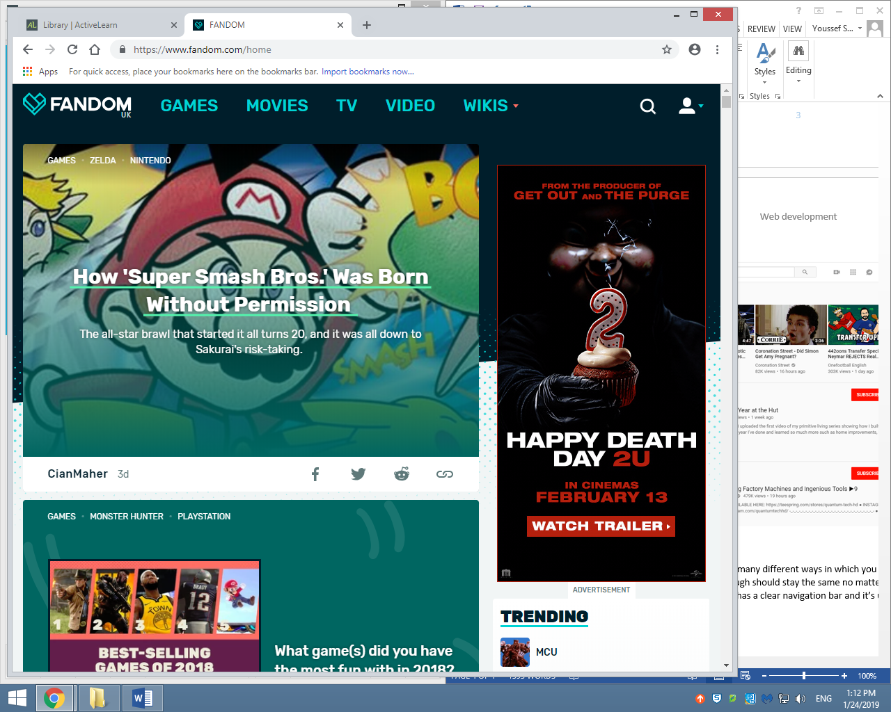This layout is the same no matter what you press on the navigation bar.

### Accessibility

Websites need to be developed in a way that all users who visit the website have equal access to the information. This is important as it removes barriers that would otherwise stop a person with disabilities for using a website, this would be a be a benefit for the organisation running the website because they are able to gain more clicks due to the way they made the website more accessible for a wider range of people. The principle of accessibility is not only for if people who are disabled can access the website, it’s also about accessing information, do people can access to information better on website then the other if so it’s more successful because people will go to the one with easer ways of accessing information.

### Example of Accessibility

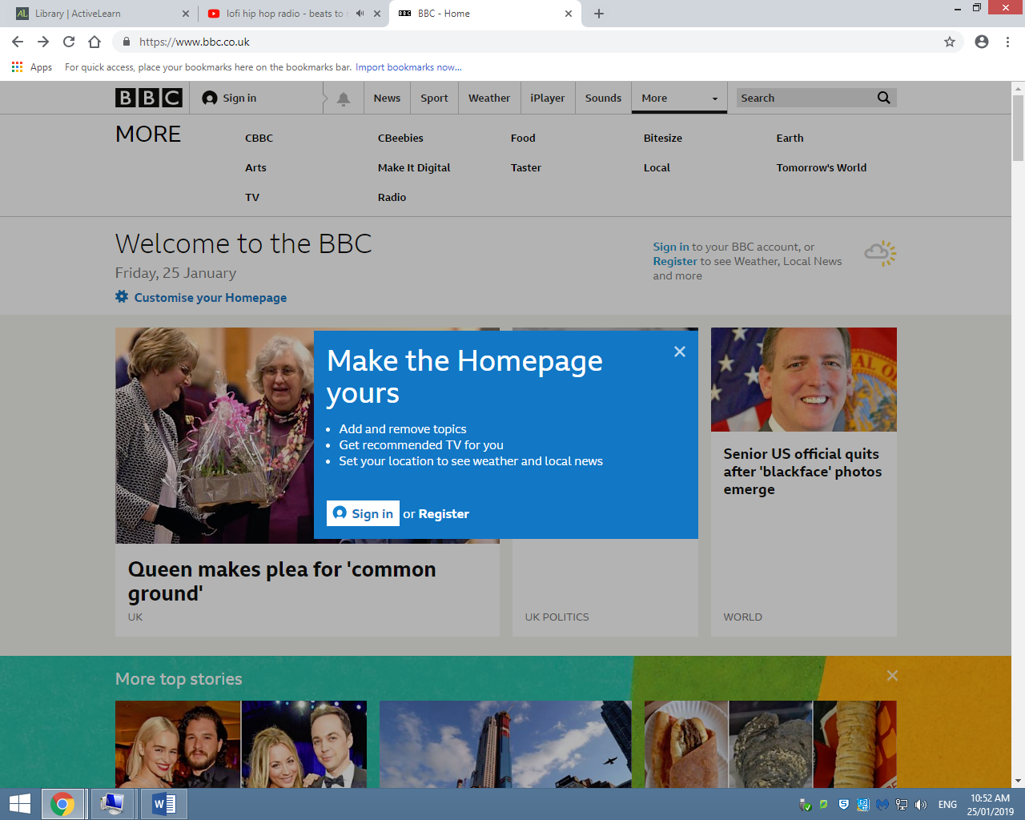For example the BBC’s website has this “customise your homepage” button which lets the user add and remove topics on the homepage to suite what type of news they want to get. It also lets the user get recommendations as well as local news and weather reports.

### Navigation

It is really important that users can navigate their way easily around the website. The navigation must be easy to understand and simple to use. Good navigation bars are very clear where the hyperlinks will take the person, this lets the user access what they want to access faster whither its information or entertainment. The navigation bar needs to be the same no matter where they go on the website, this is done like this because of the confusion it might create when they see a different navigation bar.

### Example of Navigation

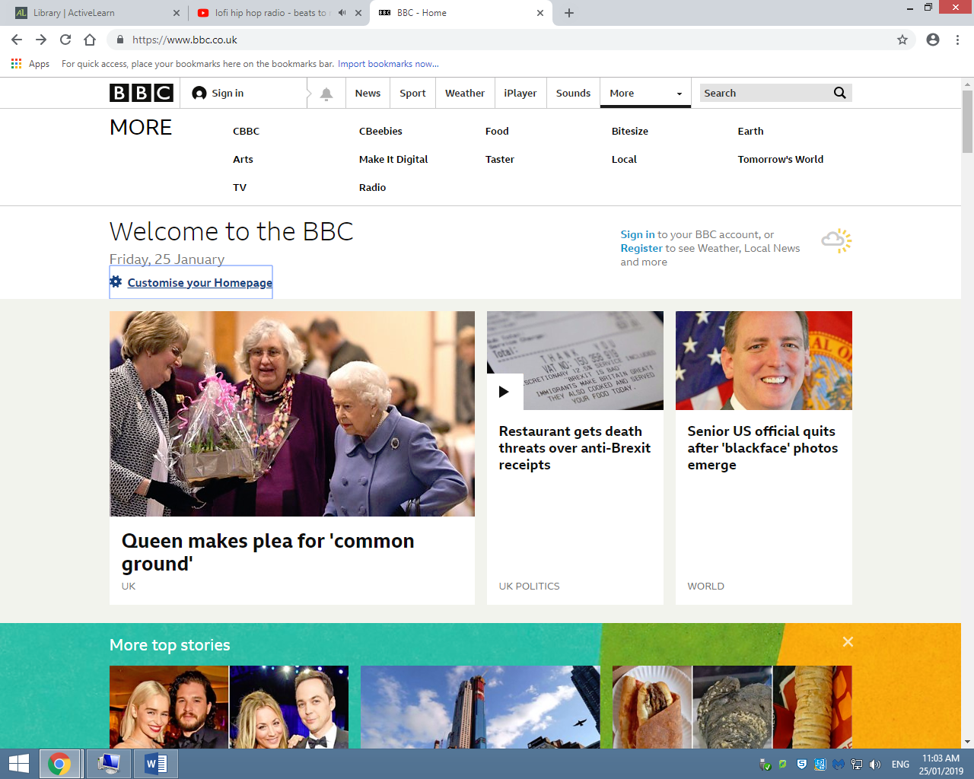

Above is the BBC navigation bar, as you can see it is very simple and easy to use, it’s clear in what it will send you to. If you want to see BBC food news or you want to see the CBeebies website they are all there. It’s very simple for the people who want information, for example the search bar next to the navigation bar. It helps the user search for the information they want.

### Typography

The type of font on the website is very important, websites need to have clear and legible text in order to be user-friendly and accessible. This lets the users read for the information they are looking for, this is important especially in websites like amazon or wikis, because they are websites that require information to be sent to the user so that they can utilise it.

### Example of Typography

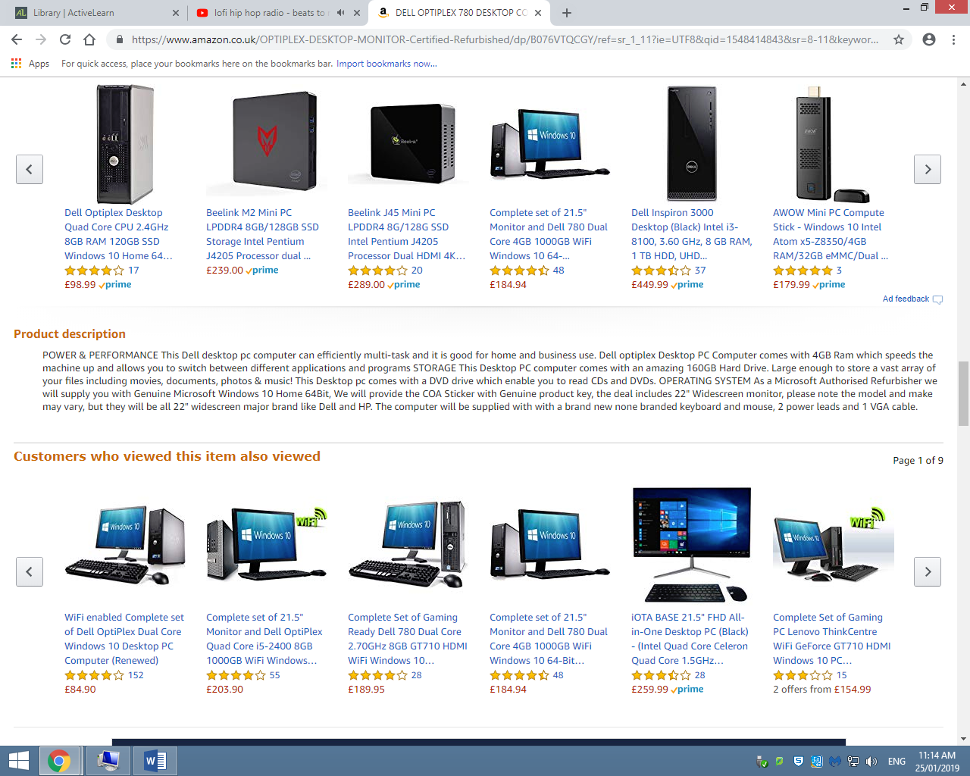

Above and below are examples of what type of font they use, for the title they make it bold and increase the font size compared to information about the item. The description is the most important thing so they try and make it clear by using the same font throughout the paragraph.

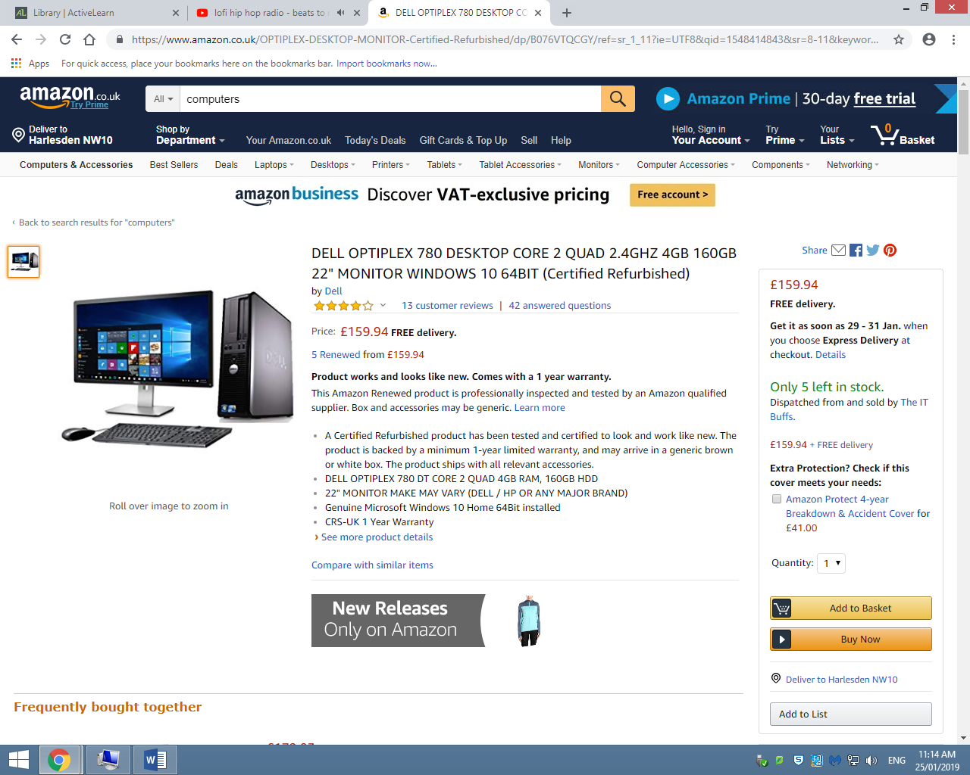

### Alignment

This is the positioning of elements on the webpage and how they are able to interact with each other. For example the placement of images next to text creates a relationship between the elements. This is used on websites like amazon and YouTube to associate titles, descriptions and prices.

### Example of Alignment

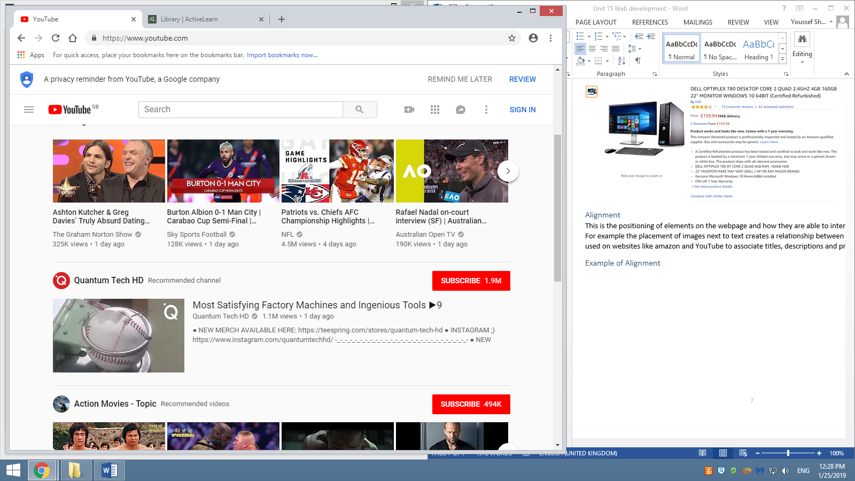This image is an example of how alignment works, the user is able to create a relationship between the image, he title and the description.

### Clarity

Being clear is the key to creating good website. It’s pointless choosing a visually appealing design if the users cannot understand it because it’s not clear. Therefore any website developer needs to keep in mind is it clear and that the information that is being communicated is able to reach the recipient.

### Example of Clarity

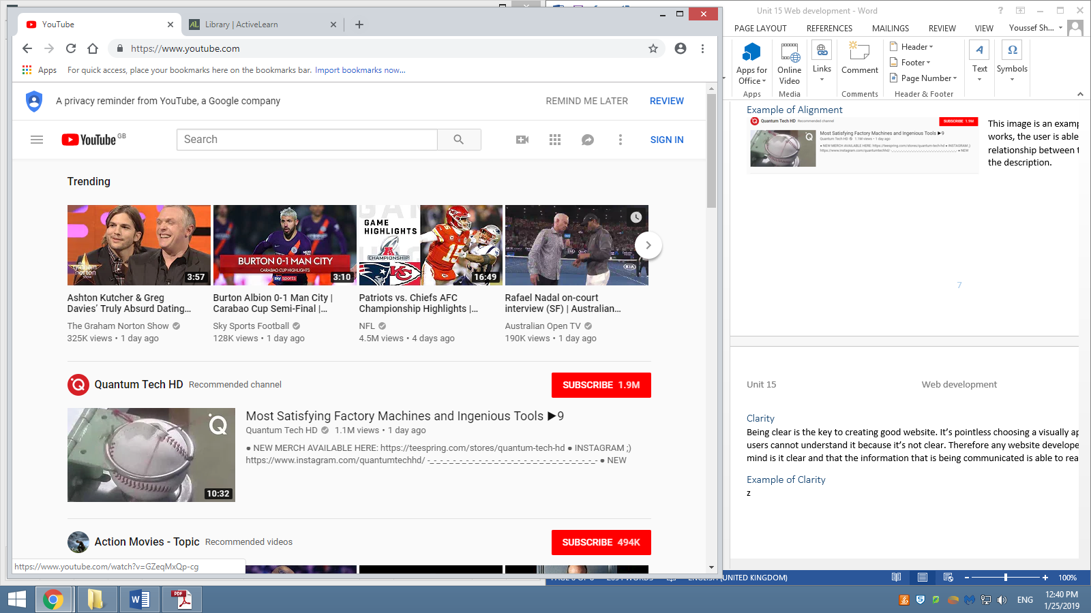YouTube is a perfect example of the use of the clarity principle, there is no fancy graphics added to the background because it would be a waste, as the purpose of the website is to let people who want to be entertained find the entertainment.

### Consistency

Consistency is the most important thing when making a website. This involves using the same page layout, the same font and the same colour scheme throughout the website. An inconsistent website is difficult to navigate, the more difficult it is to navigate to the information the less people will come to the website.

### Example of consistency

Below is a side by side comparison of the same website but different pages. As you can see they are similar but the only difference is the content. Which shows how web designers want to keep things similar.

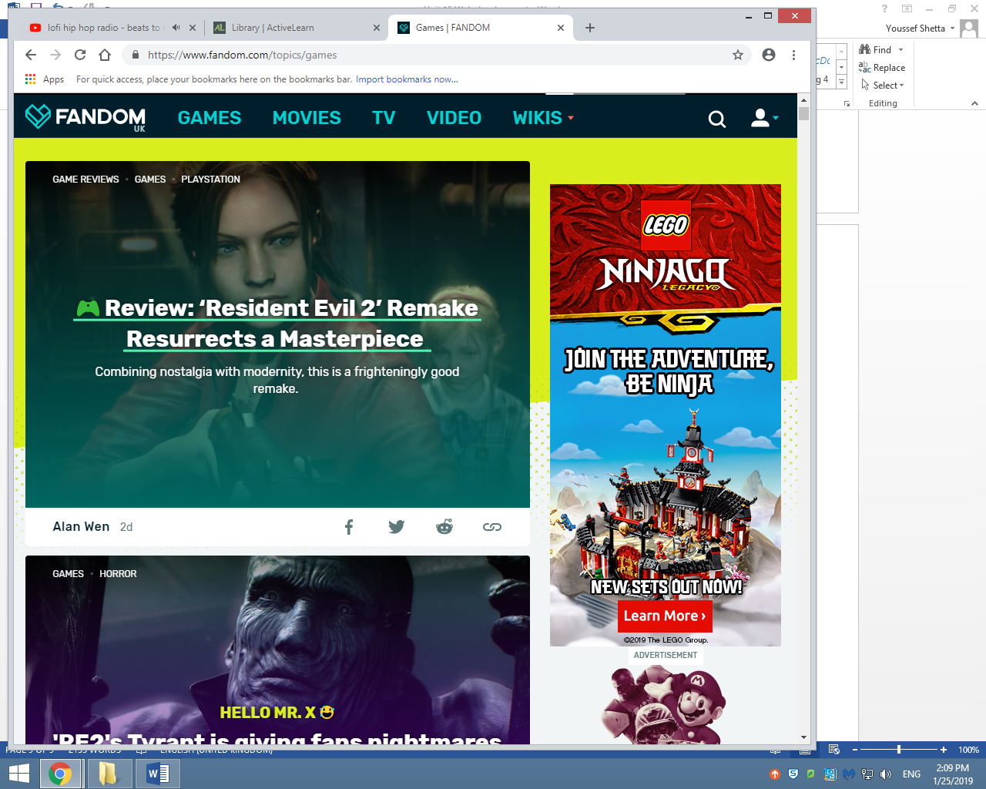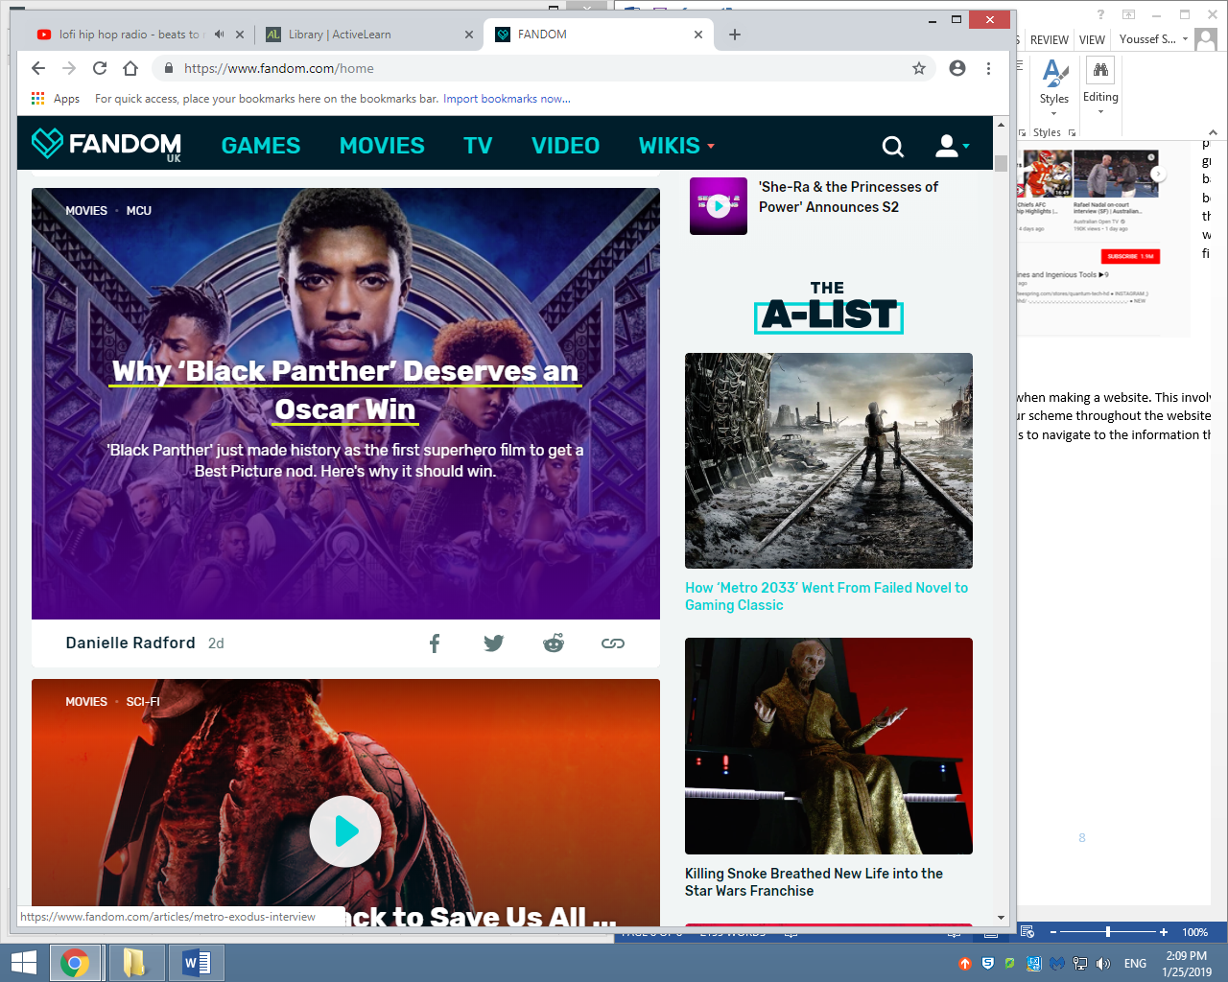

### Accuracy

Everything on the website must be accurate, it should be correct and meaningful. To keep information accurate and current the website should be updated regularly. Moreover it is more important that the information on the website is checked for factual errors as well as spelling and grammatical mistakes.

### Example of Accuracy

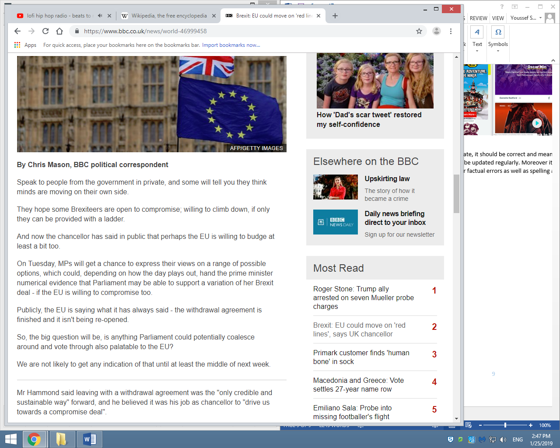Websites like the BBC need to have accurate information as they are a trusted news source.

### Content

Content of websites incudes the text, graphics as well as media and object. The content needs to be accurate and consistent in style. Also when creating the website all resources used need to be yours or you need to gain permission by the user.

### Example of content

For example the content of BBC is their own from their journalists who work for the company so they are able to upload this content to the website. The image has a water mark on the bottom to make sure that if it is stolen they have proof that the image is theirs.

### Media and objects

Some websites include interactive content, such as videos, background sounds, flash images and applets. This has to be used with moderation due to the fact that too much objects and media can slow down the site and that can put of visitors off.

### Example of media and objects

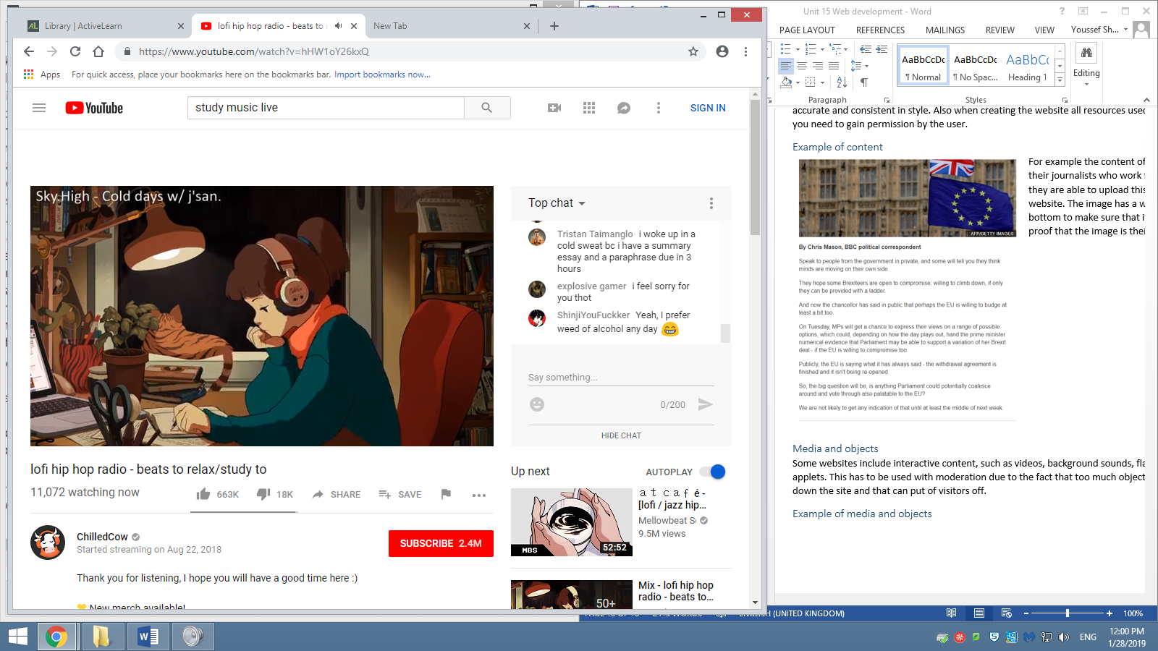This is an example of media and objects, the video is the media, and the object is the chat.

### Simplicity

Websites which are straightforward in their design are often the most visited, this is because they combine the content they need to get across with a clear and simple, easy-to-use design. The reason to why they are the most visited is because the people can reliably find the information they want.

### Example of simplicity

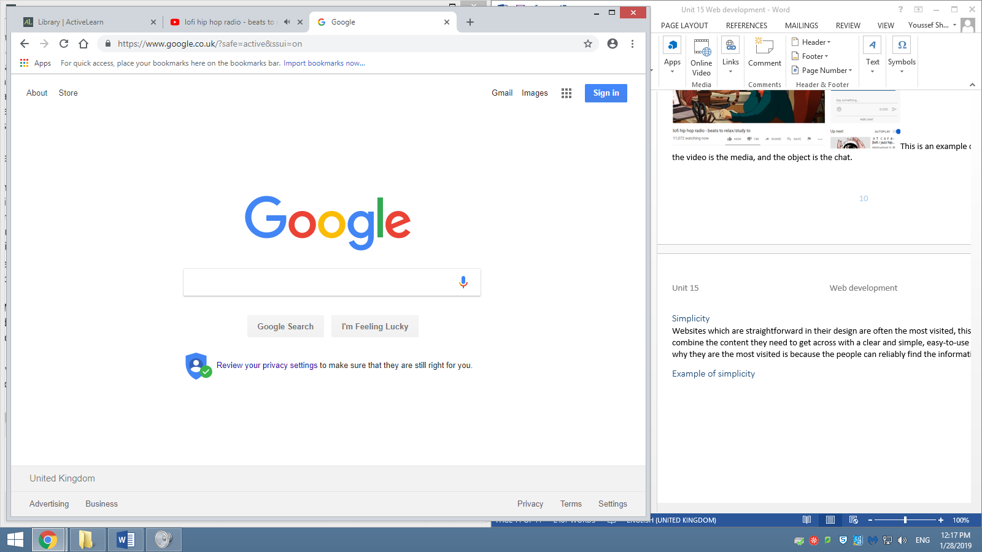Google is the prime example of simplicity, there is so much white spacing that on any other website would not work but for Google’s purpose it fits due to the fact that it’s a search engine.

## Media and objects

Below will be all the factors to consider when using media and objects.

### Position

To attract the attention of the visitor, the media and objects that are going to be implemented need to be placed in a place that they can easily see.

### Example of Position

For example, the placement of the chat is done like that because it’s not the main thing that the developer wanted to user to look at otherwise it would have been placed where the video is.

### Colour

When implementing object elements you have to consider the colour that is being displayed, is it overwhelming, if it’s overwhelming the visitor might leave because they can’t handle the colours or it’s hard to see the information they seek, there is also the problem of people who have photosensitivity, it might cause harm for the visitor which also means that the website might never be visited again by many people.

### Example of Colour

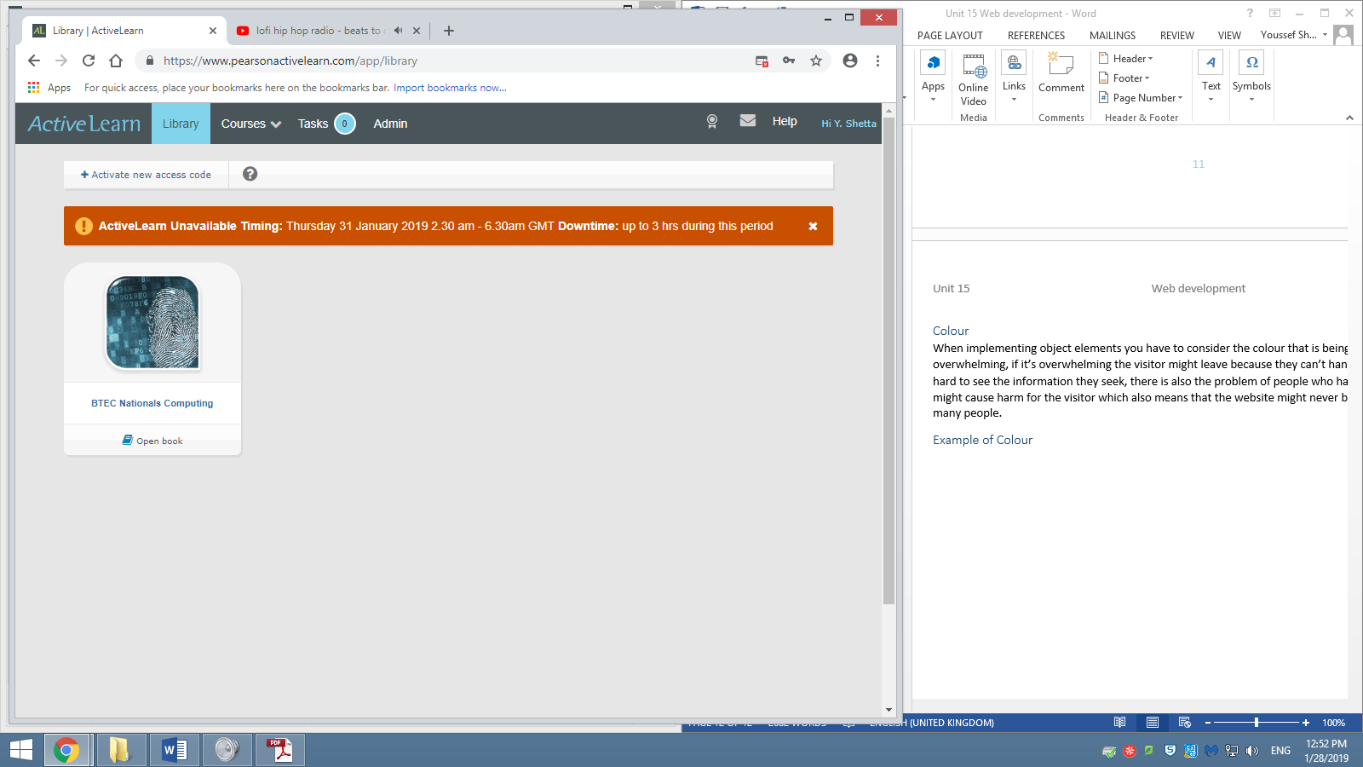For example the active learn website has a very grey tone to the website, this is because people go in there to learn from or use a textbook, this does not need flashy colours and this gives the developer a chance to put very bright colours in comparison to the background as a warning for something to happen.

### Contrast

This is used to differentiate between two or more elements on a webpage, this is done to stop the visitor from being confused between elements so that they can find or use the information/applets more easily due to the contrast differentiation.

### Example of Contrast

The contrast of the book and the background is an example of how it can be used to differentiate and make information clear, if it were to be the same colour it would be confusing if there more books next to it.

### Size

The sizing of objects and media is a concern when developing a website, if you want to capture the attention of the user it would be very easy if the thing you want them to be attracted to is big. But the downside of this if the rest of the information can fit on the page or not, and if it the information does fit on the page how much effort does the user have to go through. The more effort the user has to go through the worse the website it, because the user might just leave if they find it too tedious.

### Example of Size

The media (video) is the larger part of the website because it’s what the website is there for, it for finding videos to entertain/educate yourself. The larger it is the more probability that the user looks at it.

### Appropriateness

When adding media and objects you have to understand why you must add those features, do they make the webpage more effective. Objects and media are useful for drawing the user’s attention but there is a downside of it making the pages load longer and it might not even be mobile compatible meaning that you are limiting the audience that the website can bring.

### Example of Appropriateness

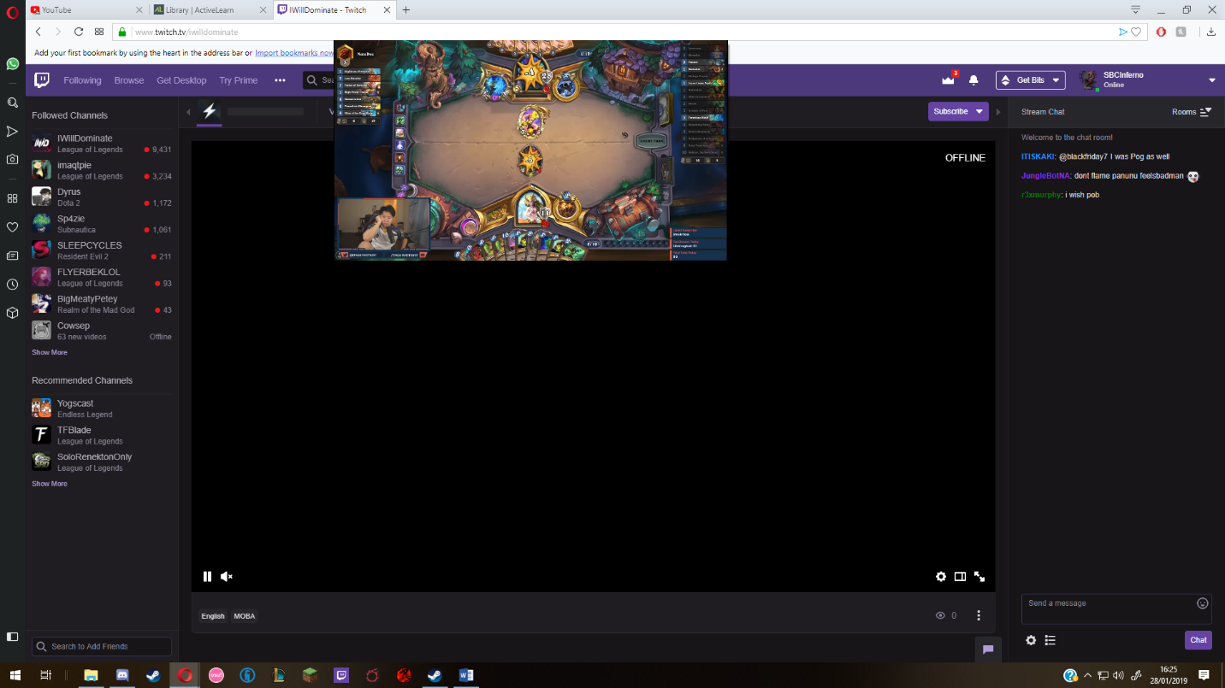For example twitch has this feature where the viewers of the livestream can talk to each other and interact with the person streaming, that is appropriate because of the type of website it is, twitch is a entertainment platform and most entertainment platforms have a way for the visitor to add a comment or chat with others.

## Creativity and innovation

There is a website about everything now a days which shows the development in website design. The more people create websites it is likely for websites to look similar, this is where the web designer’s creativity and innovation comes in, if they are creative enough, they are able to make a unique website without getting rid of information if anything it would make finding the information easier while still keeping the user on the website.

## Example of creativity and innovation

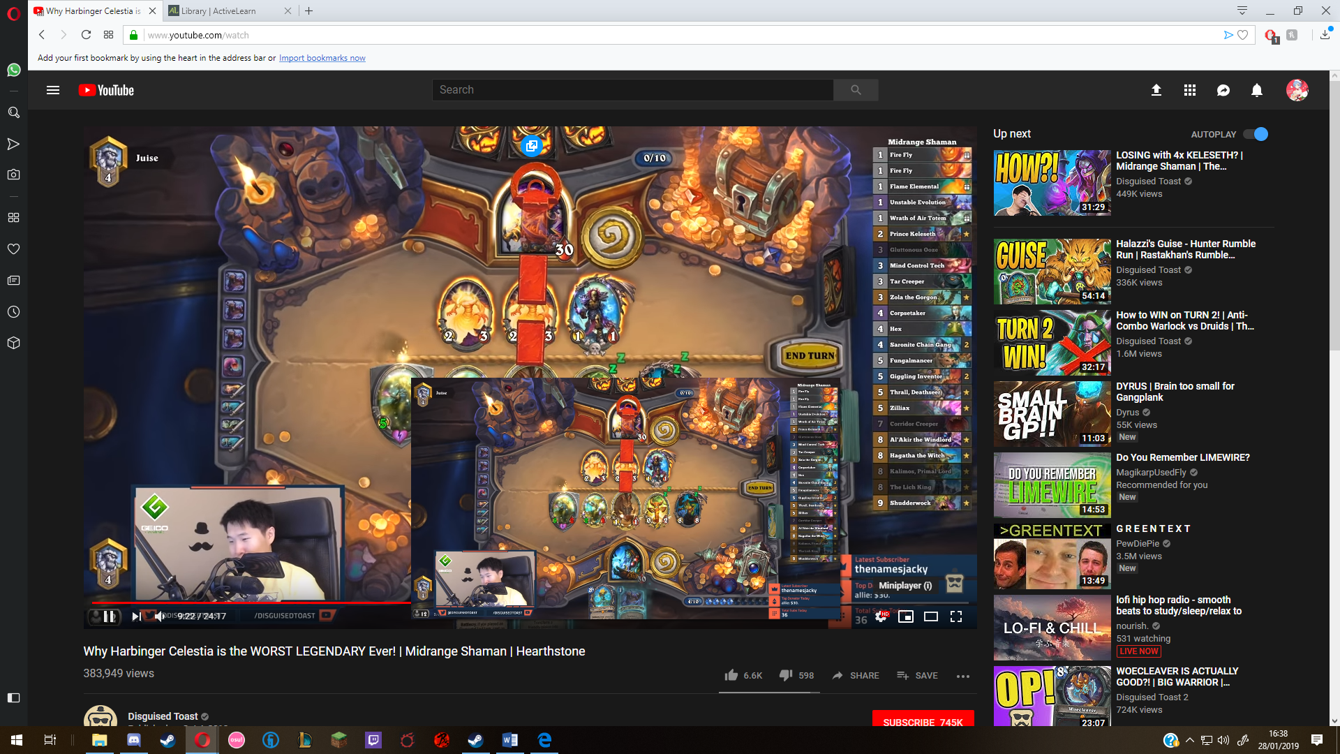For example, on YouTube they have this thing called a “miniplayer” where it has a pop out window where you are able to watch YouTube videos outside the web browser.

### Unconventional layouts (outside of the box)

Most websites follow a very basic template, which shows that most successful websites are the same because of this template. However there still needs to be enough space for innovation and creativity to be explored, this is because if something comes out that makes a website more successful people would use that and make that a part of that template. This can only be done with people who think “outside of the box” because if they keep thinking like all the other web developers nothing new will ever come out of it.

### Example of unconventional layouts

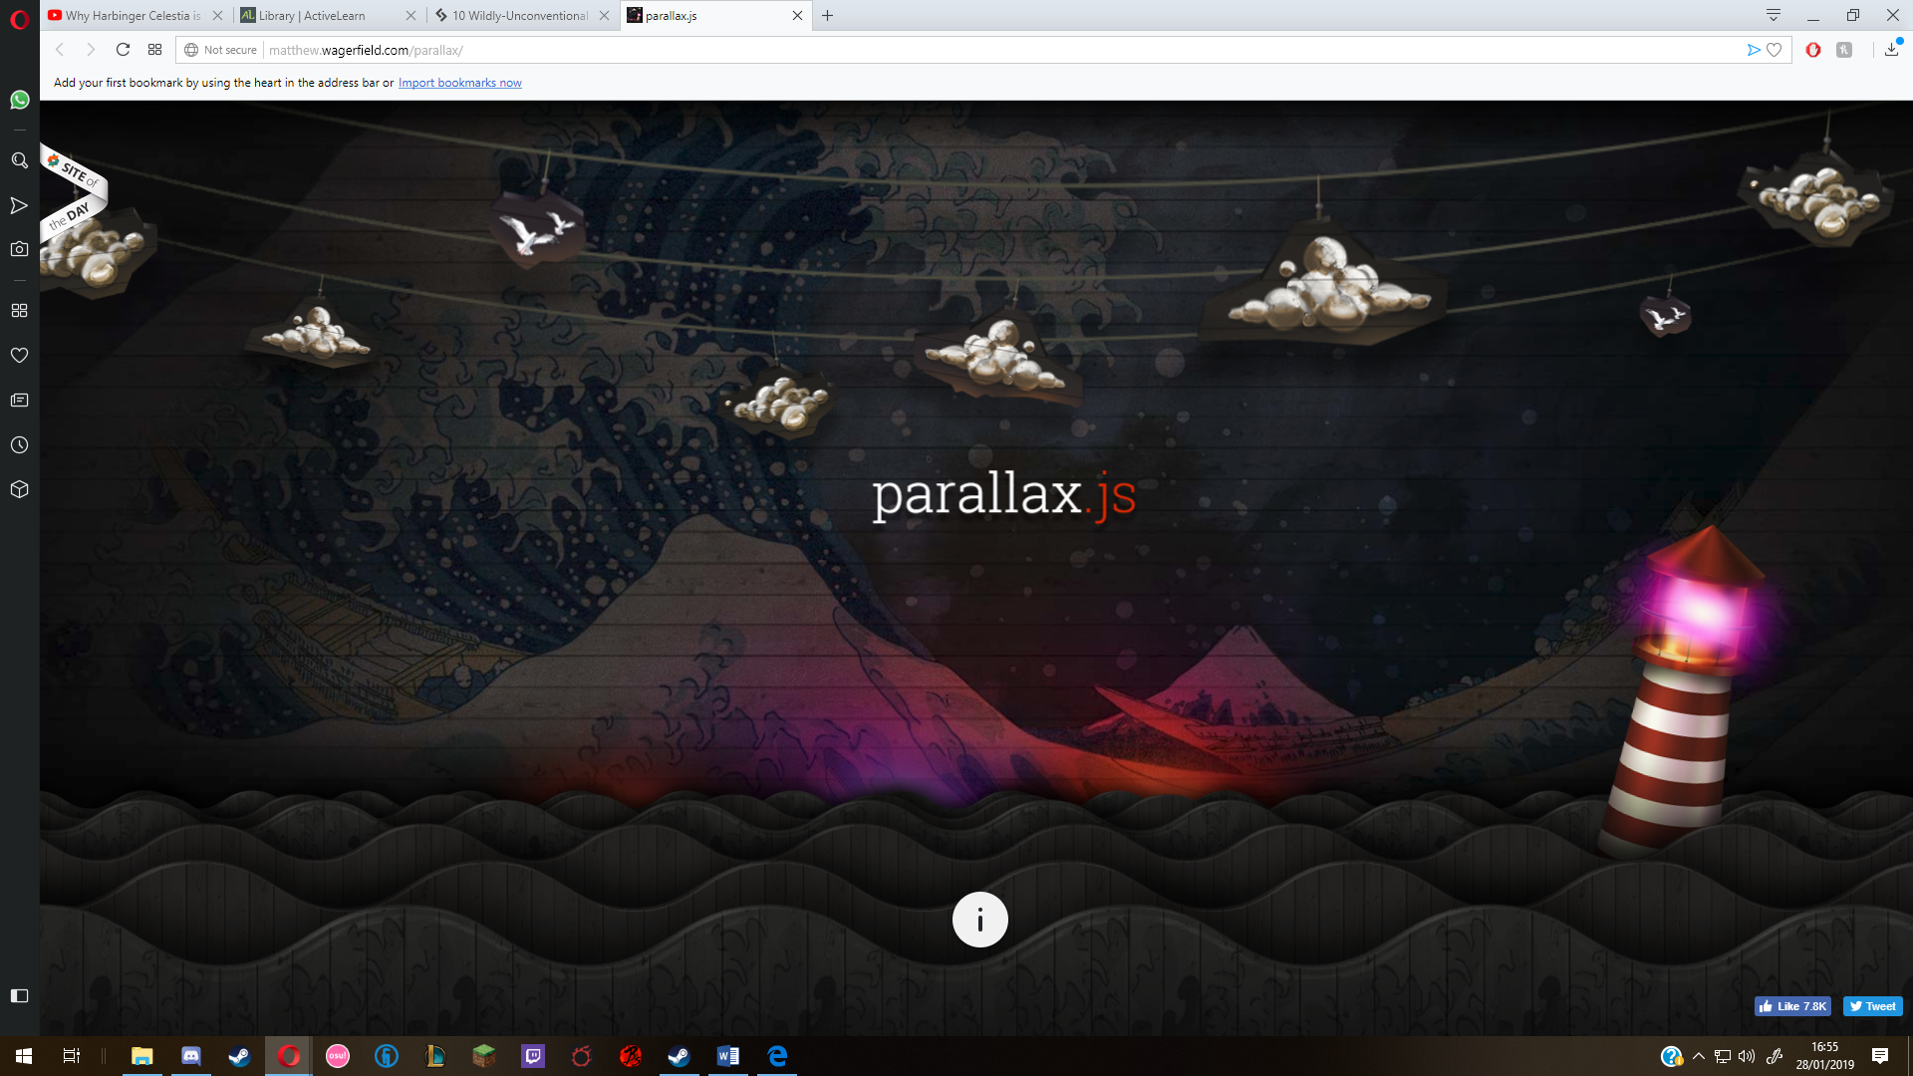

For example, the website above has a background that moves along with your mouse, this is not like your ordinary website and it express its creativity with no words but with a lot of movement and colours.

### Golden ratio

The golden ratio is a ratio that is used to make designs aesthetically pleasing, this can be applied to website design. If the web designer is able to get this golden ratio of website right it might look pleasing to the visitor, making them come back just because it looks good.

### Example of Golden ratio in websites

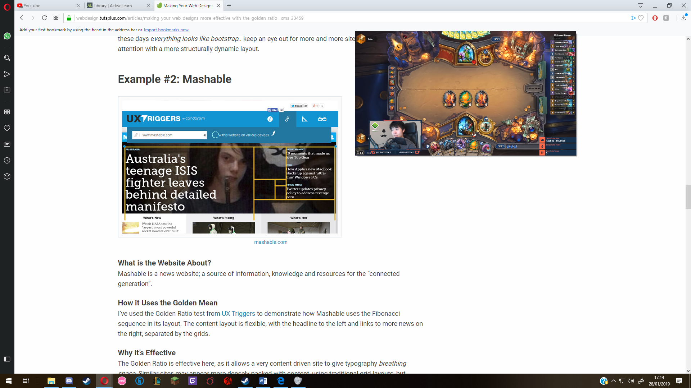The yellow lines show how the website used the golden ratio to space out the headlines, it’s effective because it gives the headlines more “breathing space”. This is good because if they are cramped together the information might not look pleasing to read and it might confuse the visitor.

## Search engine optimisation

Search engine optimisation, SEO is the name that is given to a range of techniques applied to a website to attempt to improve the ranking of the website, that means how close it is to the top when searched for or if relevant to the search how close it will be by the top to be noticed, example of search engines that help you with searching for things and what organisations want to be by the top for are Bing and google which are unpaid by the user but instead paid by the adverts that pop up when a user searches something. The theory is that the customers search for a type of product or service they will be more likely to contact the one that appears first in the search results and are very unlikely to contact organisation that do not appear on the first page of the results, that is why organisations strive to be at the top. Ways to improve the ranking of the search result would by making more accounts on that platform making it more frequent that they will see yours instead of the next one. Or attract more followers making it appear first as they will always search for that website making its ranking higher as more people click the website. Another way is by making sure all the keywords are within the content of the page as, they will eventually search something that happens to be on the site the organisation needs to improve the ranking on. 

## Example of search engine optimisation

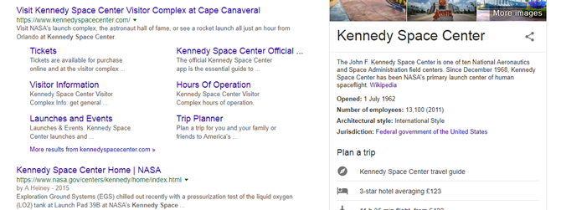

As seen here above and below the search has changed not too much but instead of the tickets and tours webpages being their own websites they are linked together with the main website. The link to the Nasa website is below the first link but it over took the tickets and tours part of the website link showing that they are still competing to be the first link

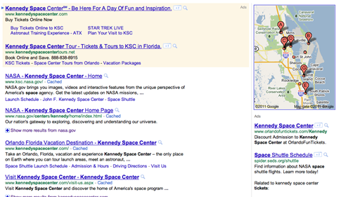

### Indexing (Meta tags)

Website developers include Meta tags in the coding of a webpage, this is usually embedded into the <head> section of the webpage. The reason they do this is because they want to ensure that the website is able to be found by the spiders, which are the things that find the websites and display them to the user depending on their searches. These tags provide information about the website to the search engine so that when searched for it will show.

### Keywords

A keyword is a word or phrase that can be put into a search engine so that it will return matching and relevant results. People take advantage of this and try and put relevant keywords that reflect what their website/business is about.

### Importance of updates

In order to ensure that your website is relevant, it must be updated regularly. If the website is updated regularly then the search engine considers it a consistent source of new information. Meaning that the more a website is updated the more successful it will be at showing near the top of a search.

# A2 Factors affecting website performance

There are a number of different factors that affect the performance of a website. If performance is affected, the websites can load slowly or fail to load completely. If that happens you are likely to lose users to more responsive websites.

## Where scripting runs

There are two places where scripts can run, it’s either on the web server or on the local client machine. Server-side scripting is used for advanced interactive features such as connecting to a database. The scrip in the page is interpreted by the server to suit the needs of the user and then it sends what is requested to the device. The downside to this is that it might slow down the experience for the user and place strain on the server. Client-side scripting is when the scrip is executed on the user’s computer and does not connect to a server. Client-side scripting is useful as it can provide extra interactivity within web pages without the need to connect to a web server.

## Browser compliance

Web browser are different then each other, it’s not only the way they look but it’s how each one renders code differently. This means that when the code of a website is loaded with a web browser it can be interpreted in a different way by the web browser to the way it would be interpreted by another web browser, this might make some websites look different on one web browser and the same on another.

## Server-side factors

Some server-side factors affect the performance of websites. I will list 3 of those factors below:

### Bandwidth availability

This determines how much traffic can be handled by the web server; specifically, how much content can be download at any one time. If the content is too big for the bandwidth it would make it difficult to download all the content at once, the larger the web page and its associated files, the less users can download from it at any one time.

### File types

Using file types that are known for their small size would help with long download times. This is because most of the small file types use a method of compression which makes all the contents of the files smaller and easier to download. When creating a website, the developer has to keep in mind if they prefer quality or efficiency, most of them will go with a balance of the two as they don’t want to sacrifice quality and they don’t want to make the download times slow.

### Number of hits

The number of web page hit can have an effect on web page performance. For example, if one page of the website is popular then it will slow down because of how many people are on it, the server won’t be able to handle the amount of people trying to visit it.

## Client-side factors

Come of the factors affecting website performance are client-sided, this can be because of the user’s computer system, and if the system is poor the user might not be able to access certain websites.

### Upload and download speeds

The speed of the user’s internet connection will affect how quickly they are able to download or upload web pages.

### Example of upload and download speeds

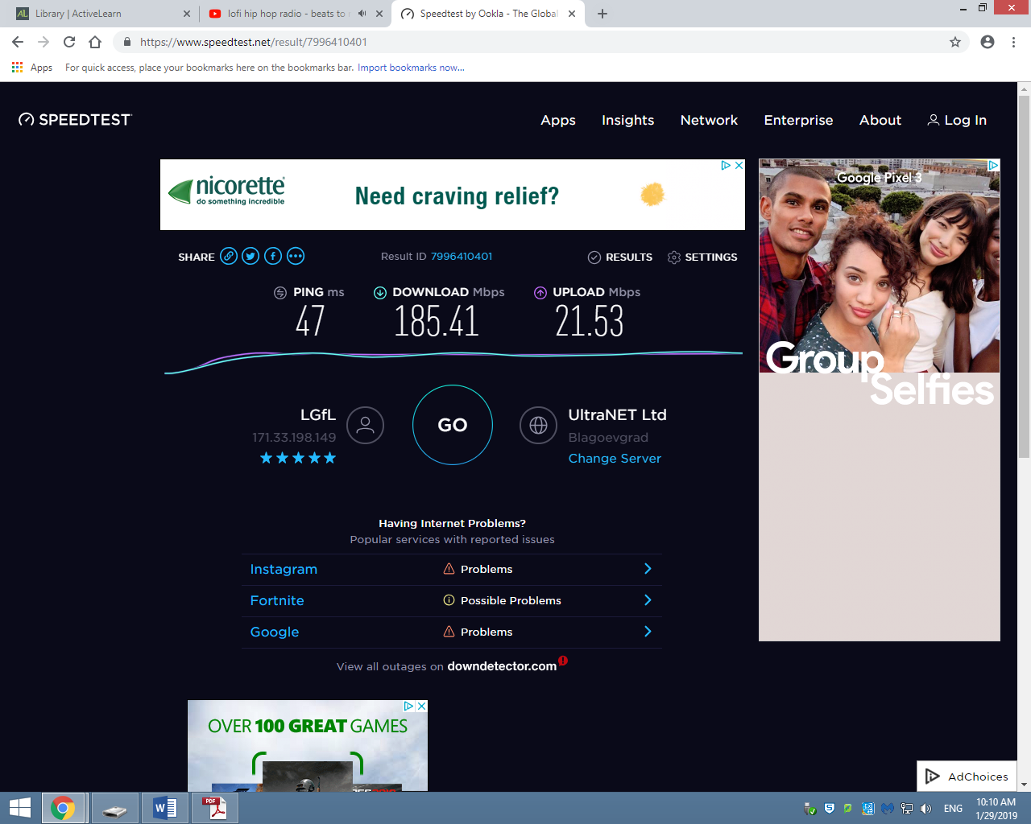users can find out their upload and download speeds in general, this can be used to find out problems to why they can’t connect to websites.

### Processor speed

The computer’s components will affect the speed with which the content is displayed and with which users can interact with it. You must take into consideration that a user’s device may not be fast so the website developer must decide between high user specification requirements and high number of visitors.

### Cache memory

The bigger the memory the faster the computer will run, the cache memory is used to reduce the average time needed to access the memory, the more memory you have the quicker your computer Is at dealing with the website you are accessing.

### Interactivity

When interactive elements are put into a webpage, such as flash images or games, this can affect the speed at which the website can load, the more the developer incorporates the more that the device trying to access the website has to download. The developer has to keep In mind how many elements they are adding, the more it is the less people will access it.

# P1 Compare the principles of website design used in two websites, including their suitability for the intended audience and intended purpose

In this section I will be comparing the websites of McDonalds and Wendy’s, they are both fast food organisations so it’s a fair comparison.

## McDonalds Aims

This is the goals that McDonalds stand by every year. They want to serve good quality food to raise the numbers on their shareholders and try to get a good return on them.

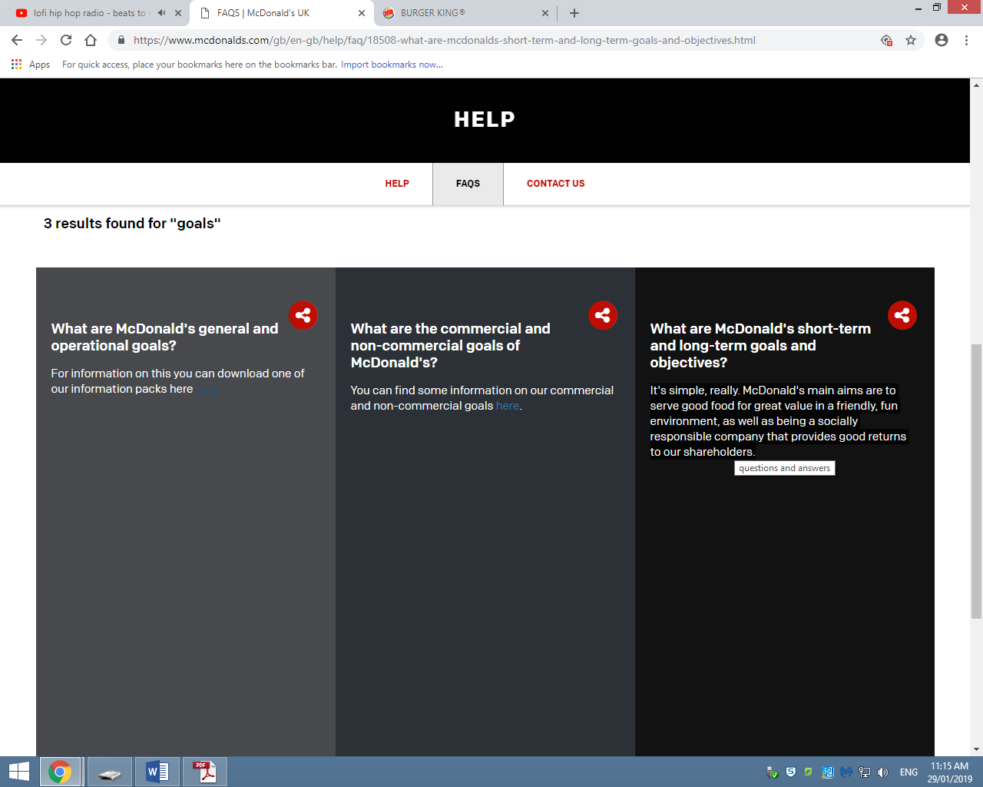

## Wendy’s Aims

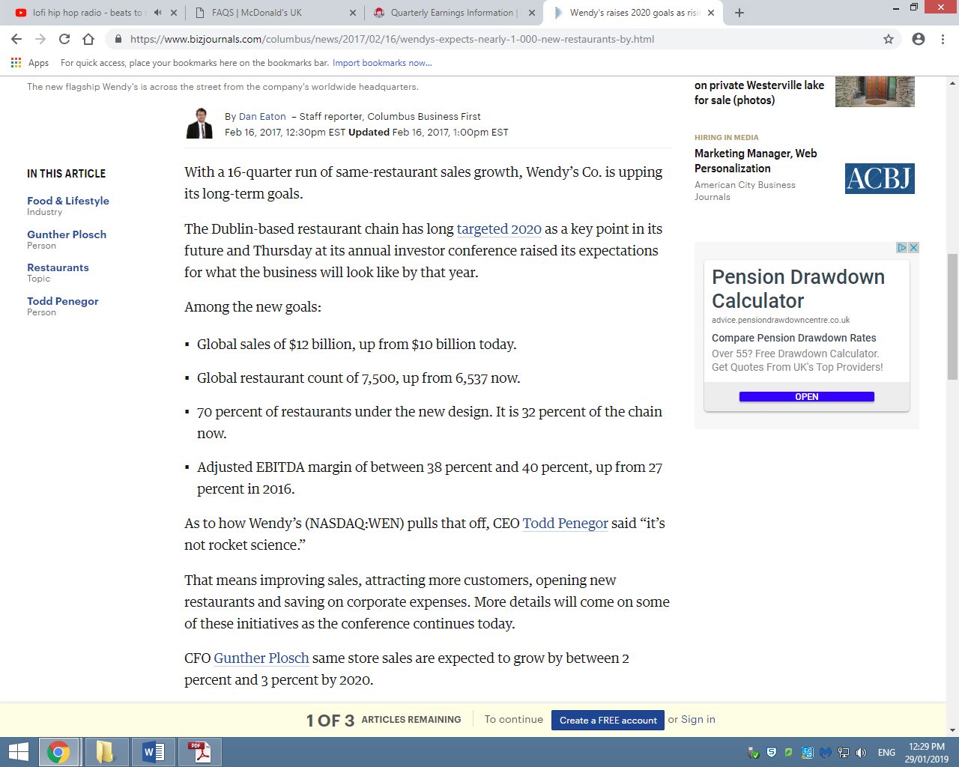

## McDonalds

The reason to why McDonalds made a website is because they want to make people come to their store by showing tools for the user to use to direct them to their store, for example the menu is displayed so the user can use this and they are able to just go to the store and order knowing what they can get.

McDonalds does not have many white-spaces, if at all. This makes their website over whelming but the information that an information-seeker would want is there and the navigation bar is clear to help find that information. They also have the option to track down the nearest McDonalds to you. Which fulfils the accessibility function for the organisation in general and not just for the website, this is because they are able to gain customers without advertisements, this meets their business aim by getting more customers they raise their statistics which they can use to get a return on their shareholders. For example they might present data like the amount of traffic they get on their website to the shareholders compared to other competitors like Wendy’s. As seen below McDonald’s has a lot more total visits than Wendy’s showing that their website works. However Wendy’s gets more visit duration, page per visit and less bounce rate showing that they have something on their website that keeps the users on it. This could be the “order online” implementation which can make people stay on the website longer as they would have to input data to the website to get their order through. An explanation to the bounce rate being so high for McDonalds could be the fact that the person is looking for one piece of information and once found they leave the website.

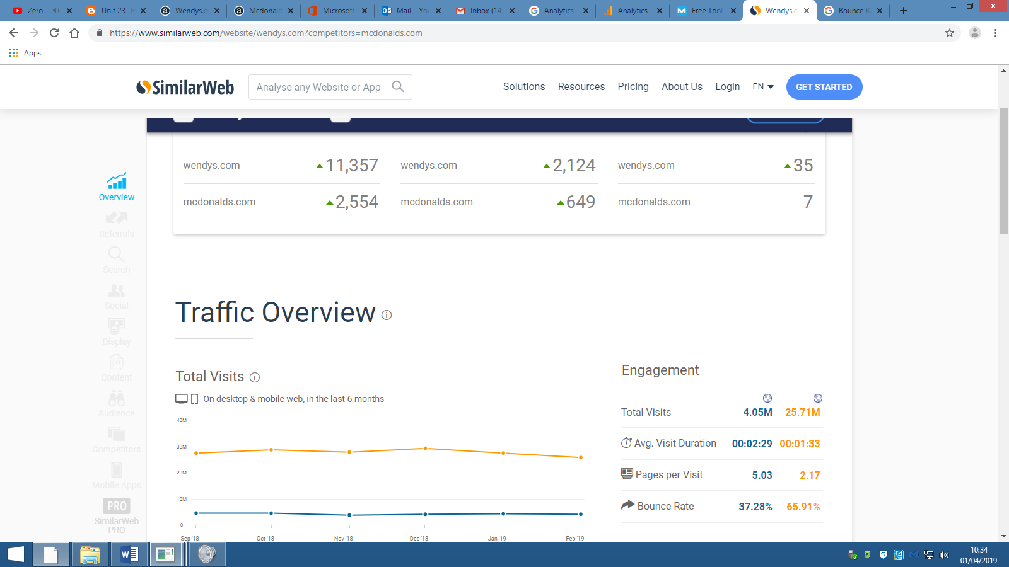

The navigation bar is simple and easy to access, even when scrolling down you are able to access it, this is fulfilling the principle of navigation and accessibility, as well as consistency because no matter where I go on the website, I am able to access the tabs that are shown to be by the navigation bar and it never changes.

Furthermore, on the principle of accessibility they implemented the change of languages on their website, so if there is a need to change language they can. This opens up to more people accessing the website because people can understand the content. Which also fulfils the principle of content.

Finally, McDonalds uses alignment to try and portray as much information as they can with the pictures that they put up in the background, there are multiple on the page which might confuse someone about what is going on.

## Wendy’s

The reason why Wendy’s made a website is because they want it to increase the amount of sales they get at each store, if they are able to gain an online audience they can earn more by getting them to buy their products. They do this by using website principles to keep the visitors coming.

When visiting their website the first thing you see is a big picture of their new event where they give out a free “Baconator” which is one of their burgers. They use the principle of alignment to add information on the picture that you are introduced to. McDonalds also does this, they put huge pictures of their food to make people stay around by grabbing their attention with bug pictures of food. People will most likely visit these website when they are hungry looking for a way to order online.

Also just like McDonalds they have a menu where a visitor can order from, this helps them meet their business aim of increasing sales by $10 billion. Making a new way for people to order from the company means more money because there is more platforms to gain money from. Wendy’s noticed this can created an application for phones where people can order while being mobile.

Unlike McDonalds Wendy’s navigation bar does not scroll down with you so there is more effort involved when trying to access the information and serviced on the website. Similarly to McDonald’s the white-spacing on Wendy’s website is the same, they both have no white spacing and everything looks very compact, which can be a bad thing because if all the information is all together it can become confusing which could make visitors not come back.

# M&D1 Analyse & evaluate how the principles of website design are used to produce creative, high performance websites which meet client requirements.

Both McDonalds and Wendy’s have similar business aims as well as website designs. This may be because of the template that their web developers are using. However one is more advanced in web creation than the other because of the way they have dealt with the navigation bar. McDonald’s website design is clearer and more consistent than Wendy’s website design, which has a disappearing navigation bar, since the navigation bar is very hard to navigate the website with, which makes it harder for the website to appeal to potential visitors. There is also proof of McDonalds being more successful than Wendy’s based on website ranking: McDonalds’ website is ranked 6,414 while Wendy’s website has the ranking of 21,834.

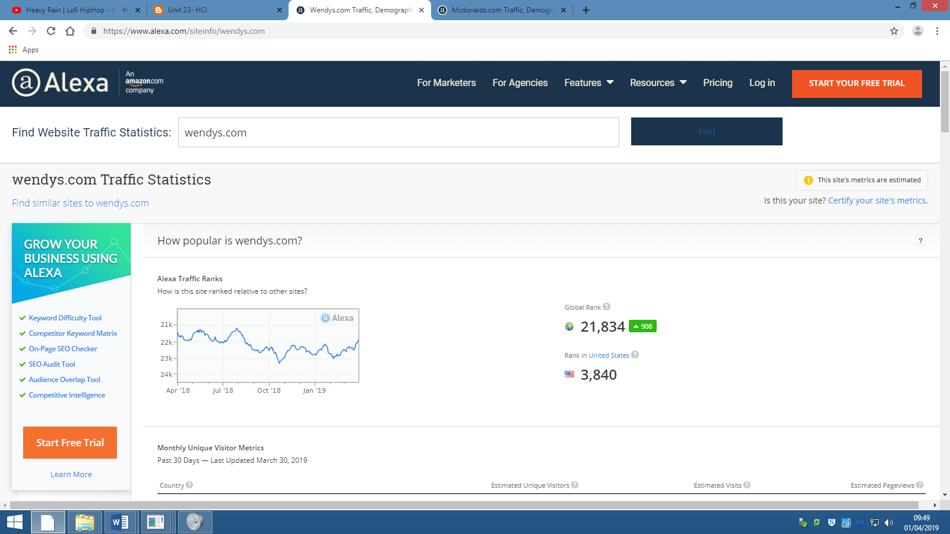 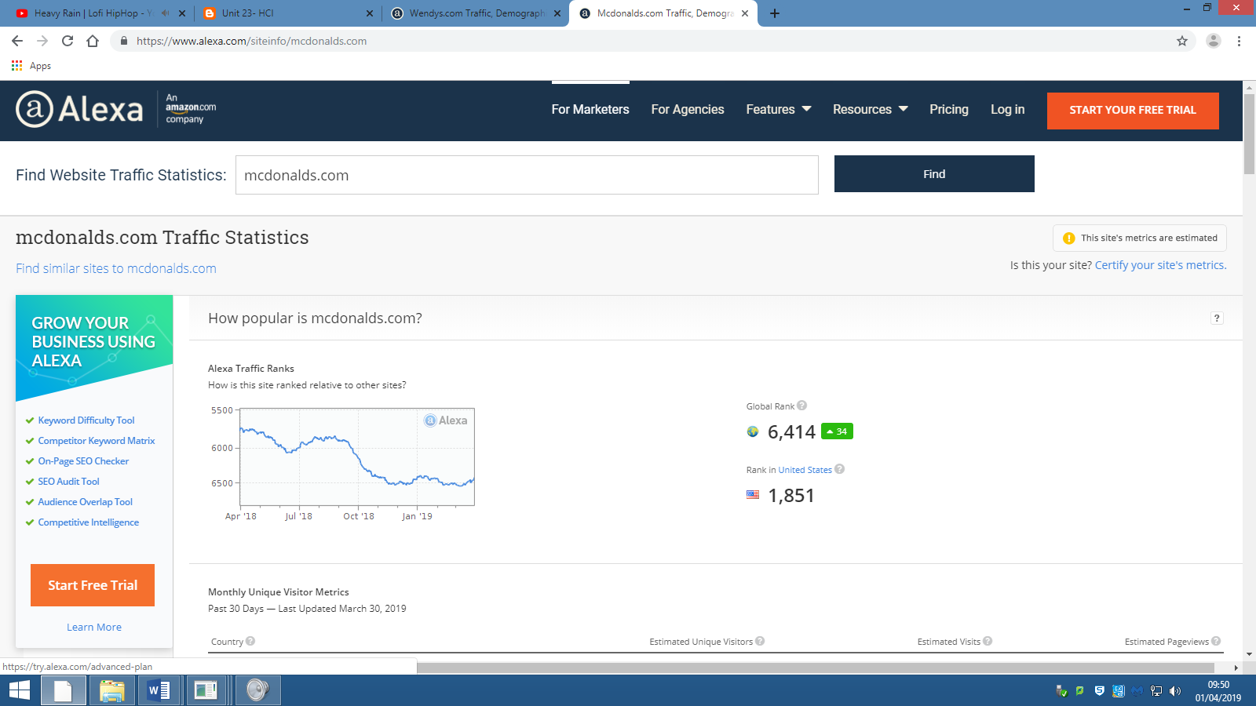

A way for McDonalds to improve on their website, to help meet their business aims, would be to add an “order online” section to their website so that people can order from different platforms, allowing their business to grow because of how many channels they have to order from. As they have walk-in fast food restaurants all over the world, it wouldn’t hurt to add another way for people to order and get it delivered. McDonalds have already done this, but instead of websites they use phone calls and delivery services like Deliveroo. These services would help with meeting the requirements of the business, as well as help optimise their website to fit the needs of the visitors, as this service would be server side making the processing on the visitors’ computer less of a strain for them. It also makes it more secure, as their data will be stored on their server and not on their local drive, so it’s harder to pinpoint the data. If they include this service it would fall under the principle of accessibility, since people are able to access their service more if they added that feature.

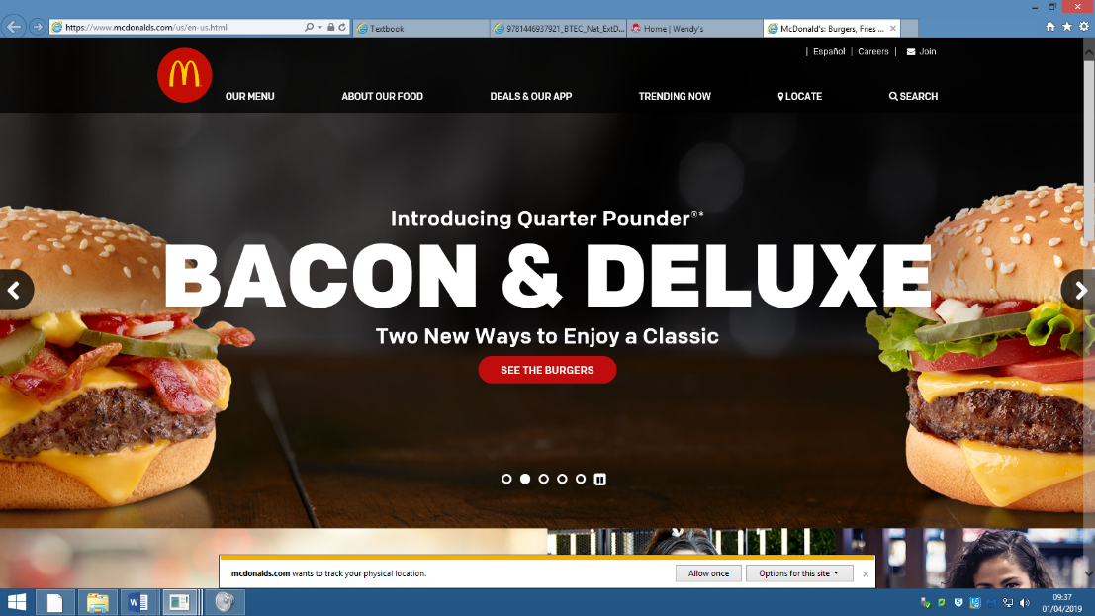As seen in the screen shot there is not an “order now” button that lets the user order from their website, if there is it’s not clear enough and is not practical. And because of this it is non-e-commerce, as there is no way for people to purchase anything off their website.

However, since McDonald’s website is not for e-commerce purposes, but more for providing information to visitors, as there is no option to purchase anything from the website. All the website has is information about new and upcoming events, as well as a menu that visitors can’t interact with. This shows us that the goal of the website is for promotion purposes, which is updated every time there is something new coming to McDonalds. For example, on the 3rd February McDonalds posted on their twitter about the new “classics with bacon” event, which is also on their website. This shows that the website serves the exact same purpose as their social media, which is to promote new events.

Wendy’s website being ranked lower than McDonalds does not mean that it doesn’t meet the client’s requirements. There are some features on Wendy’s website that aren’t seen on McDonald’s website. For example, they have an “Order Now” button at the top of their website so that the customer has 3 options of getting their order through. Improving the accessibility of the ordering service increases the amount of sales, which then helps meet their business aim of trying to gain more global sales. This uses principle of accessibility to help meet their aims of raising their revenue.

Here are the three ways that people can order from Wendy’s. And all this is on their website for promotion and accessibility.

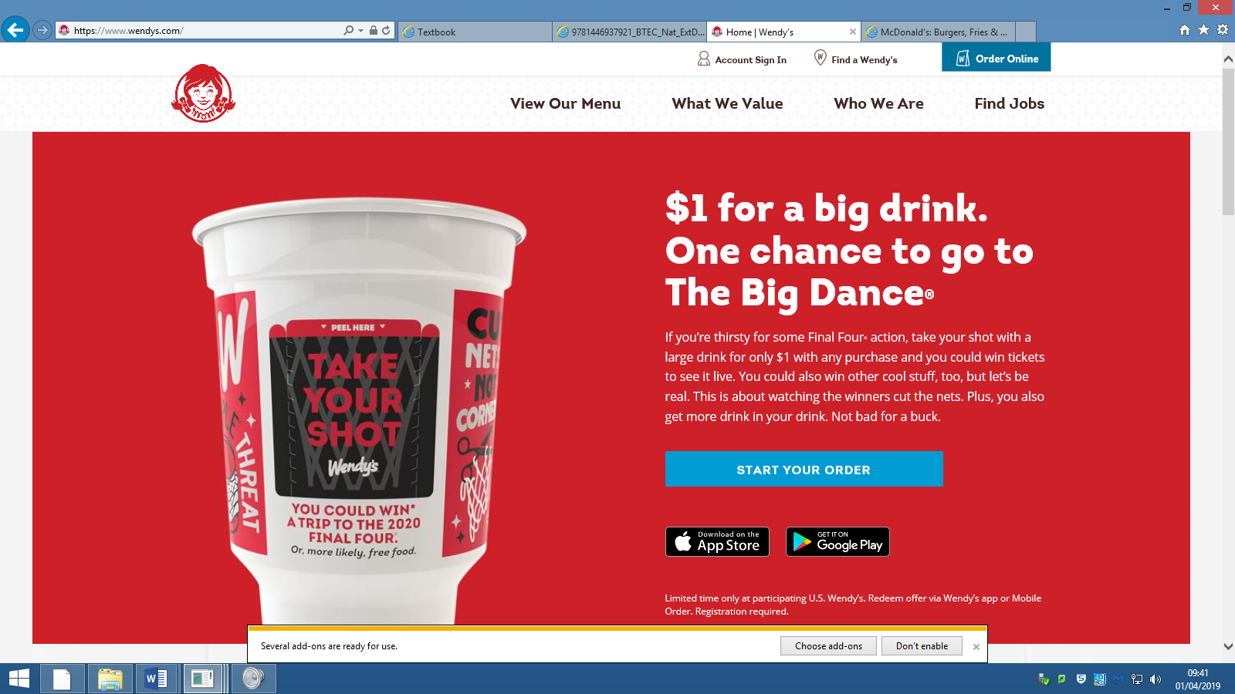

Furthermore Wendy’s has a “Find a Wendy’s” on their website which also helps meet two of their business aims at the same time; this lets a visitor of the website find the nearest restaurant which then in turn gets more sales for the organisation. The website also has an investor relations page, which lets investors and people who want to own a restaurant from the chain gain confidence, as there are numbers out in the open for people to see. This meets their aim of having more restaurants open by the end of 2020, because people will have information to prompt them into investing into the organisation.

In conclusion Wendy’s has been developing ways for people to order, making their products more accessible then McDonalds. However, McDonalds’ website still has a higher ranking then Wendy’s website because they were founded 10 years before Wendy’s. There is also the way that McDonalds took the route of information instead of services, which shows that their promotion works more effectively then Wendy’s. McDonalds can improve in trying to meet their business aims by adding more accessibility features to their website to their services by adding an “Order Now” button, where people can order from. This would help meet the aim of returning their shares to their shareholders, as they would be getting more sales.

# Bibliography

Pearson BTEC National computing student book was used from A1 purpose and principles of website products to the end of A2 factors affecting website performance. Pages 496-504.

P1, M1 and D1 were based on McDonald’s website and Wendy’s website.

<https://www.mcdonalds.com/us/en-us.html>

<https://www.wendys.com/>

The business aims that I found for Wendy’s was found from:

<https://www.bizjournals.com/columbus/news/2017/02/16/wendys-expects-nearly-1-000-new-restaurants-by.html>

The business aims that I found for McDonalds was found from:

<https://www.mcdonalds.com/gb/en-gb/help/faq/18508-what-are-mcdonalds-short-term-and-long-term-goals-and-objectives.html>

Statistics:

McDonald’s:

<https://www.alexa.com/siteinfo/mcdonalds.com>

Wendy’s:

<https://www.alexa.com/siteinfo/wendys.com>